Network Intelligence Gathering Activity
Scenario:
You are a security analyst for a company that has recently added several new systems to its internal network. Before conducting any further security assessment, you need to identify which hosts are currently active on the subnet 192.168.10.0/24.

Task:
Perform a ping sweep on the network 192.168.10.0/24 using Kali Linux to discover all live hosts. Record the IP addresses of the active systems and prepare a brief report listing the reachable hosts. Based on your findings, explain how ping sweep results can assist an attacker during the reconnaissance phase and discuss two security measures that can reduce the effectiveness of ping sweeps on an organization's network.

Expected Outcome:
Identification of active hosts on the subnet.
List of reachable IP addresses.
Analysis of reconnaissance value.
Recommended defensive measures against host discovery.
Step 1: Verify Network Configuration
Open the Kali Linux terminal and verify that the system is connected to the target network.
Command:
ip addr
Step 2: Perform a Ping Sweep
Use Nmap to discover all live hosts on the network.
Command:
sudo nmap -sn 192.168.10.0/24
The -sn option performs host discovery only and does not scan ports.
Observe the Output
The scan identifies the devices that respond to ping requests.
Sample Output:
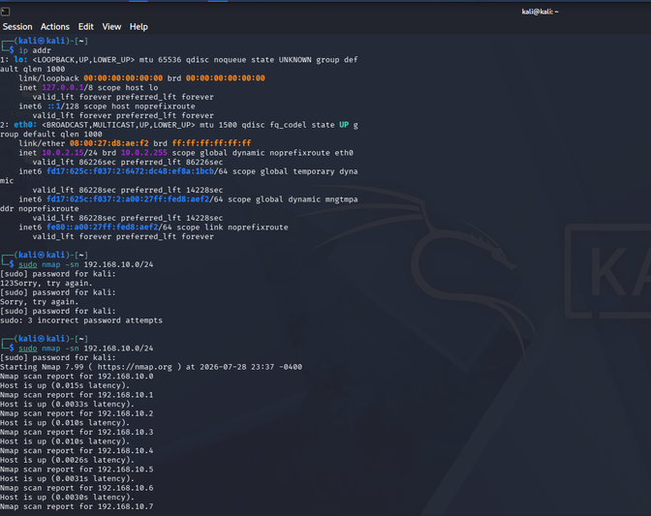

Step 5: Analyze the Results
The ping sweep successfully identified the active systems connected to the 192.168.10.0/24 subnet. These hosts are reachable and can be selected for further security assessment, such as port scanning, service enumeration, or vulnerability analysis.
Step 6: Reconnaissance Value
A ping sweep is commonly used during the reconnaissance phase to identify live systems on a network. It helps attackers or security analysts determine which hosts are active, reducing the number of systems that need further scanning. This information can be used for additional security testing or vulnerability assessment in an authorized environment.
Step 7: Defensive Measures
- Restrict ICMP traffic using firewalls to prevent systems from responding to ping requests.
- Use network segmentation and IDS/IPS to detect scanning activity and limit the spread of reconnaissance across the network.
Result
The ping sweep on the 192.168.10.0/24 subnet was completed successfully using Kali Linux. Active hosts were identified and recorded. The activity demonstrated the role of ping sweeps in network reconnaissance and highlighted defensive measures such as ICMP filtering, network segmentation, and IDS/IPS to reduce the effectiveness of host discovery.

